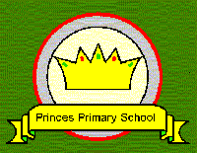 | Princes Primary School
ORDER FORM FOR SCHOOL UNIFORM

Name of Child: ________________________________ Class: _____________

CARDIGAINS COST - £10.00
Size 22”-24”  (age 3-4) | Size 26”-28”  (age 5-6) | Size 30”  (age 7-8) | Size 32”  (age 9-10) | Size 34”  (age 11-12) | Small Adult

SWEATSHIRTS COST - £8.00
Size 22”-24”  (age 3-4) | Size 26”-28”  (age 5-6) | Size 30”  (age 7-8) | Size 32”  (age 9-10) | Size 34”  (age 11-12) | Small Adult

POLO SHIRTS COST - £7.50
Size 22”-24”  (age 3-4) | Size 26”-28”  (age 5-6) | Size 30”  (age 7-8) | Size 32”  (age 9-10) | Size 34”  (age 11-12) | Small Adult

BOOK BAGS COST - £4.00 PUMP BAGS COST - £2.50

Total amount enclosed: £__________________

Please make all cheques payable to PRINCES PRIMARY SCHOOL

